Graphic Approval Process

Accessing Posted Graphics for Approval

Reviewing Graphics in the GPJ Annotator

Notification of File Status Changes

Accessing Posted Graphics for Approval

- Login to the GPJ Annotator by entering your ID and password and click “Go!”
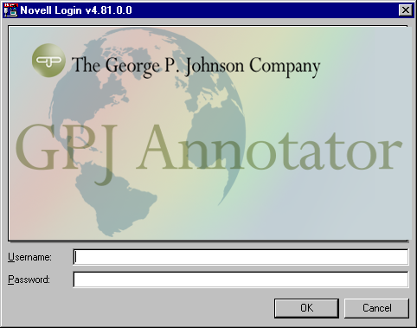
- Enter the Graphics module of the Annotator application by clicking the “Graphics Handler & Annotator” option.


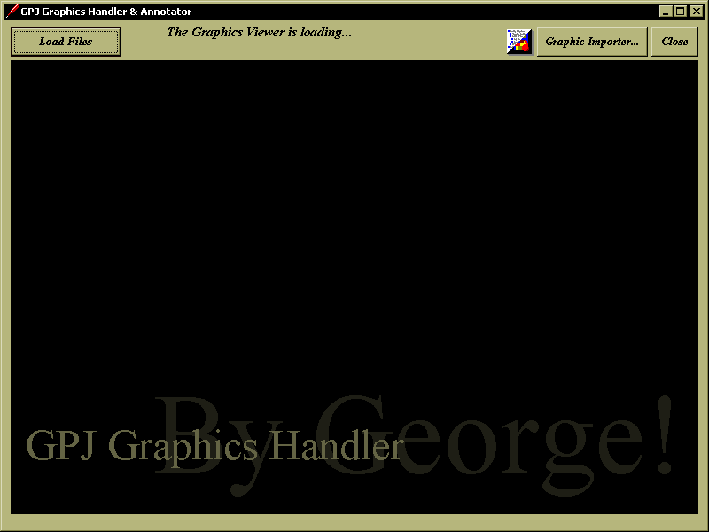

- Click on the “Load Files” button in the upper left corner to access your Client’s Graphics.
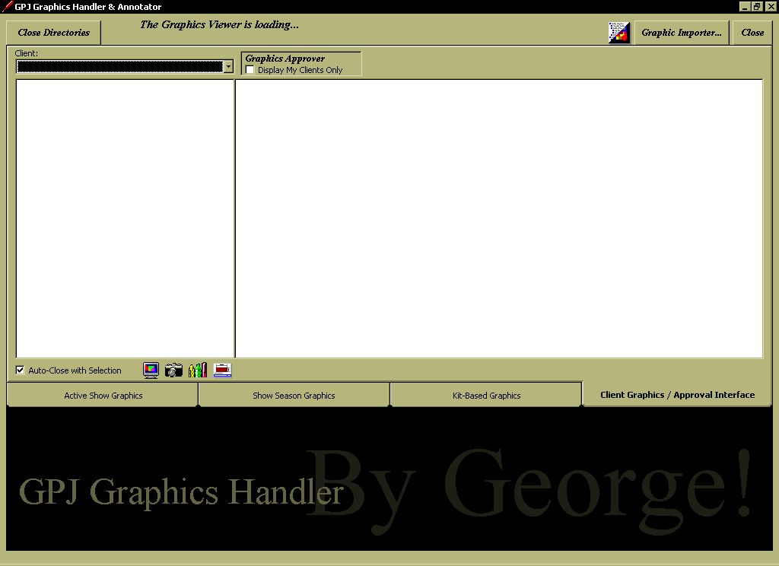
(Return to Top)

Reviewing Graphics in the GPJ Annotator

- A “Graphic Approver” is a member of a Client Team who has been given the authority to change the Status of a Graphic File. Most Graphics will be posted to the Annotator by the Graphics Designer as a “Draft” status file. “Draft” files are only viewable on the Annotator by internal GPJ personnel. In order to allow external Clients to view a Graphic, its status must be raised to “Released” or “Approved”, via this interface. Moving the status of a Graphic or a Layout File to “Approved” will also prompt the Designer to move the Graphic into Production.

- If you are a “Graphic Approver” for any Client, you will notice a couple of changes to the interface, above. The “Client Graphics” tab is now called the “Client Graphics / Approval Interface” tab, and on that tab you will see a small box named “Graphics Approver”. Those users who are not “Graphic Approvers” will still only see “Client Graphics” as the tab name. By checking the option “Display My Clients Only”, your “Client:” list will only display those Clients you have rights to change status for. Un-checking the option, returns the list of all Clients you have rights to view.

- Upon selection from the “Client:” listbox, a list of status folders will appear.
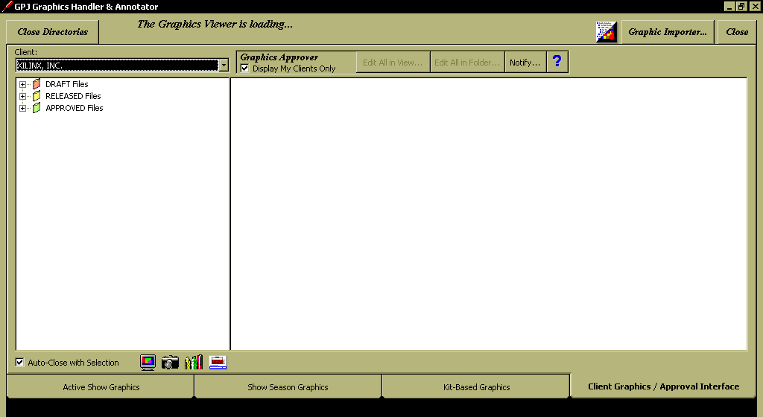

NOTE: If you are entering the interface to review Graphic Files, you have probably received an automated email (similar to the one shown below) requesting you to do so. The email was sent from the Graphic Importer application by the Graphics Poster. This email should list the files you are searching for.
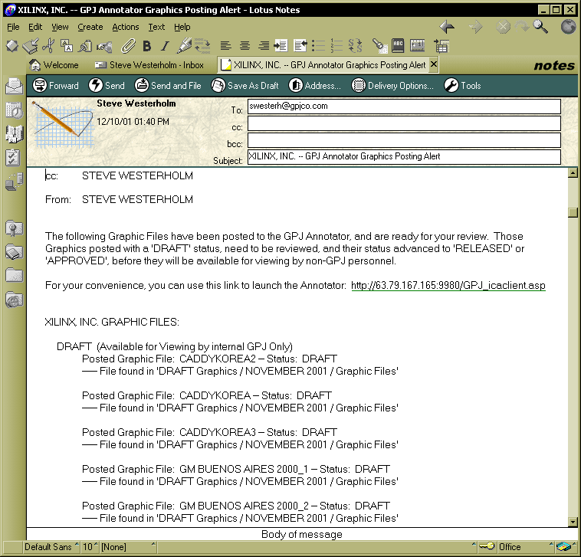

- In this example, we will navigate to the “DRAFT/November 2001/Graphic Files” folder (as listed in the email). Click on the treeview node to display thumbnail views of all the files in the folder.
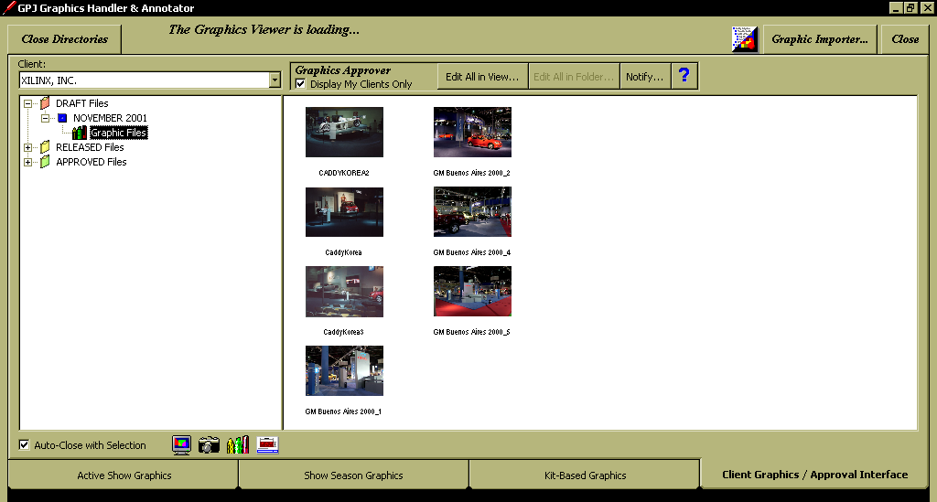

- You will notice that the “Graphic Approver” box has expanded to display four buttons.
- “Edit All in View…”
- “Edit all in Folder…” (This button is enabled only if the folder holds more than twenty files.)
- “Notify…”
- “?” (Selection will display this file.)

- There are three ways to reset a Graphic’s Status:
  - You can edit files one-at-a-time. By right-clicking on the thumbnail view of a file, you can select one of the options available. If the file is currently a “Draft” file, that option will drop off, but the other two will be available, plus the option to “Reset Status as ‘CANCELED’”. A “Canceled” status is similar to a delete.
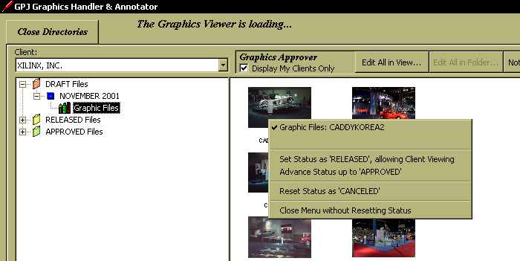

  - To reset the status of all the files in the current thumbnail viewer (the viewer holds a maximum of twenty files), click on the “Edit All in View…” button. A popup menu will provide you with options similar to those described above, but selection will affect all the files in the view.
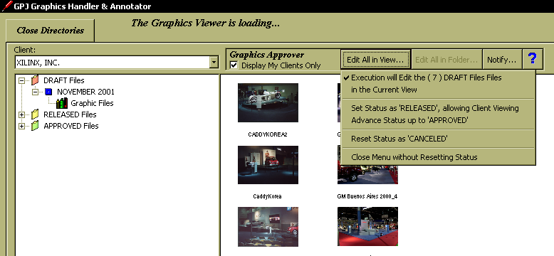

  - If a folder holds more than twenty files, the “Edit All in Folder…” button will become enabled. Clicking on this button will bring up a menu similar to the popup above, but selection will edit all the files in the current folder.

- Once the status has been reset on a Graphic file, the file will be removed from the current view. You may notice that the file will not automatically appear in its new folder. This will not occur until a “Notify…” has been initiated. This process is identical to that required in the Graphic Importer, and remember, similar to the Graphic Importer; the file is in “limbo” until a notification has been completed. It is not available for viewing by anyone.

- NOTE: You can reset the status of a File forwards, or backwards. There is nothing to prevent you from resetting an “Approved” file back to “Draft” status. This change will require a notification to complete, just as a forward change does.

(Return to Top)

Notification of File Status Changes

- Once a Graphic File status has been edited, a notification of its availability must be made before it will be again viewable in the GPJ Annotator. Clicking on the “Notify…” button brings up the following menu.
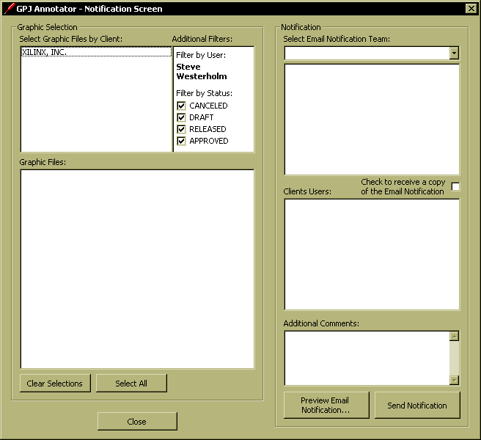

This interface will display all the posted graphic files that are waiting for notification. Unlike the Graphic Importer (which displays all awaiting files), this interface only shows files that you have reset the status for. You will notice the filter showing your name is not editable, but the others are.

NOTE: If you go to exit the Graphics Handler interface, and have edited the status of a Graphic, without sending out a notification, you will receive the following prompt reminding you of the existence of non-notified files.
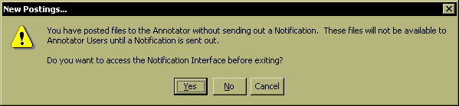

“Yes” takes you to the interface, “No” allows you to exit, but you will be reminded during future sessions until a notification is sent out. Also, remember the files will not be available for viewing until the notification occurs.

- From the “Select Graphic Files by Client:”, choose the graphic Client whose files you will be notifying. Once chosen, a list of all their non-notified files will populate in the “Graphic Files:” listbox, based on the current additional filters.
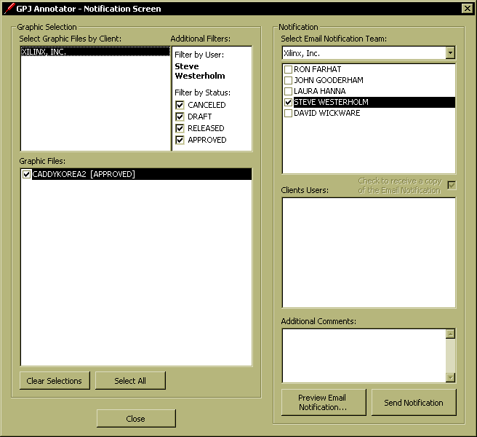

- In order to easily group notification files use the “Additional Filters:” options. Filters include an option to “Filter by Status:”. These filters provide the ability to select only “Canceled”, “Draft”, “Released” or “Approved” files, or any combination of the three. Ultimately, the “Graphics List:” files can be individually checked, or unchecked.

- In order to complete the notification process, it is necessary to have had a Client Email Notification Team setup in the Annotator. If no Team has been setup, the “Notification” section of the interface will be disabled. In this situation, contact the A/E and have them arrange to have a Team created. It is a simple process to setup the Team, but it should be initiated by the A/E. In most situations, a Team will already have been setup, since you cannot send out an alert of posted files from the Graphic Importer, without having had a Team previously setup.

- If an Email Notification Team has been set in the Annotator, the Team associated with your “Client:” selection will populate in the “Notification” section. The Team members setup as Graphics Mandatory Recipients (those who will automatically receive notifications of all newly posted Graphics, Comments and Annotations) will be pre-selected, or checked. These Team members cannot be un-selected. Also, if you are not a member of the Email Notification Team, you may check the option to send yourself a copy of the notification for your records.

- If any “Client Users” (non-GPJ personnel) have been setup with Annotator access for the selected “Client:”, these users will display in the “Client Users:” listbox. If checked, these Client Users will be alerted of “Released” and “Approved” graphics only. A ”Draft” graphic is intended for internal viewing only. Even if a Client User is setup as a Graphics Mandatory Recipient for an Email Notification Team, they will not be notified of “Draft”-status resets.

- “Additional Comments:” can be added in the provided textbox. Any comments entered here will be included in the automated email to all those checked in either the “Email Notification Team” listbox, or the “Client Users” listbox.

- To verify the contents of the outgoing email as correct, click on the “Preview Email Notification…” button, to review the outgoing message.
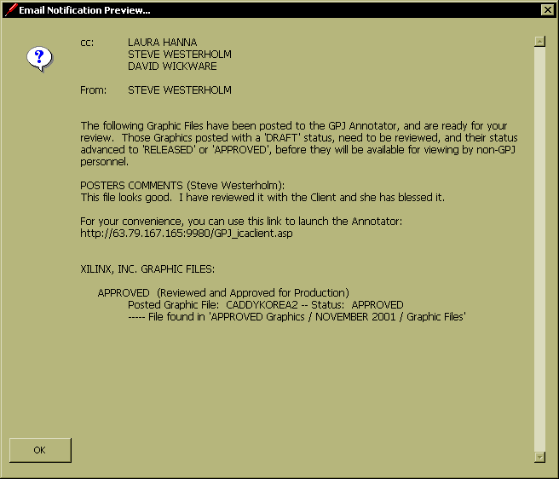

- If the preview is acceptable, close the “Preview” window, and click on “Send Notification” to complete the process. Upon return to the Graphic Interface, you will need to refresh the Client data, by re-selecting the “Client:” from the listbox, to see the file in its new location.

(Return to Top)

